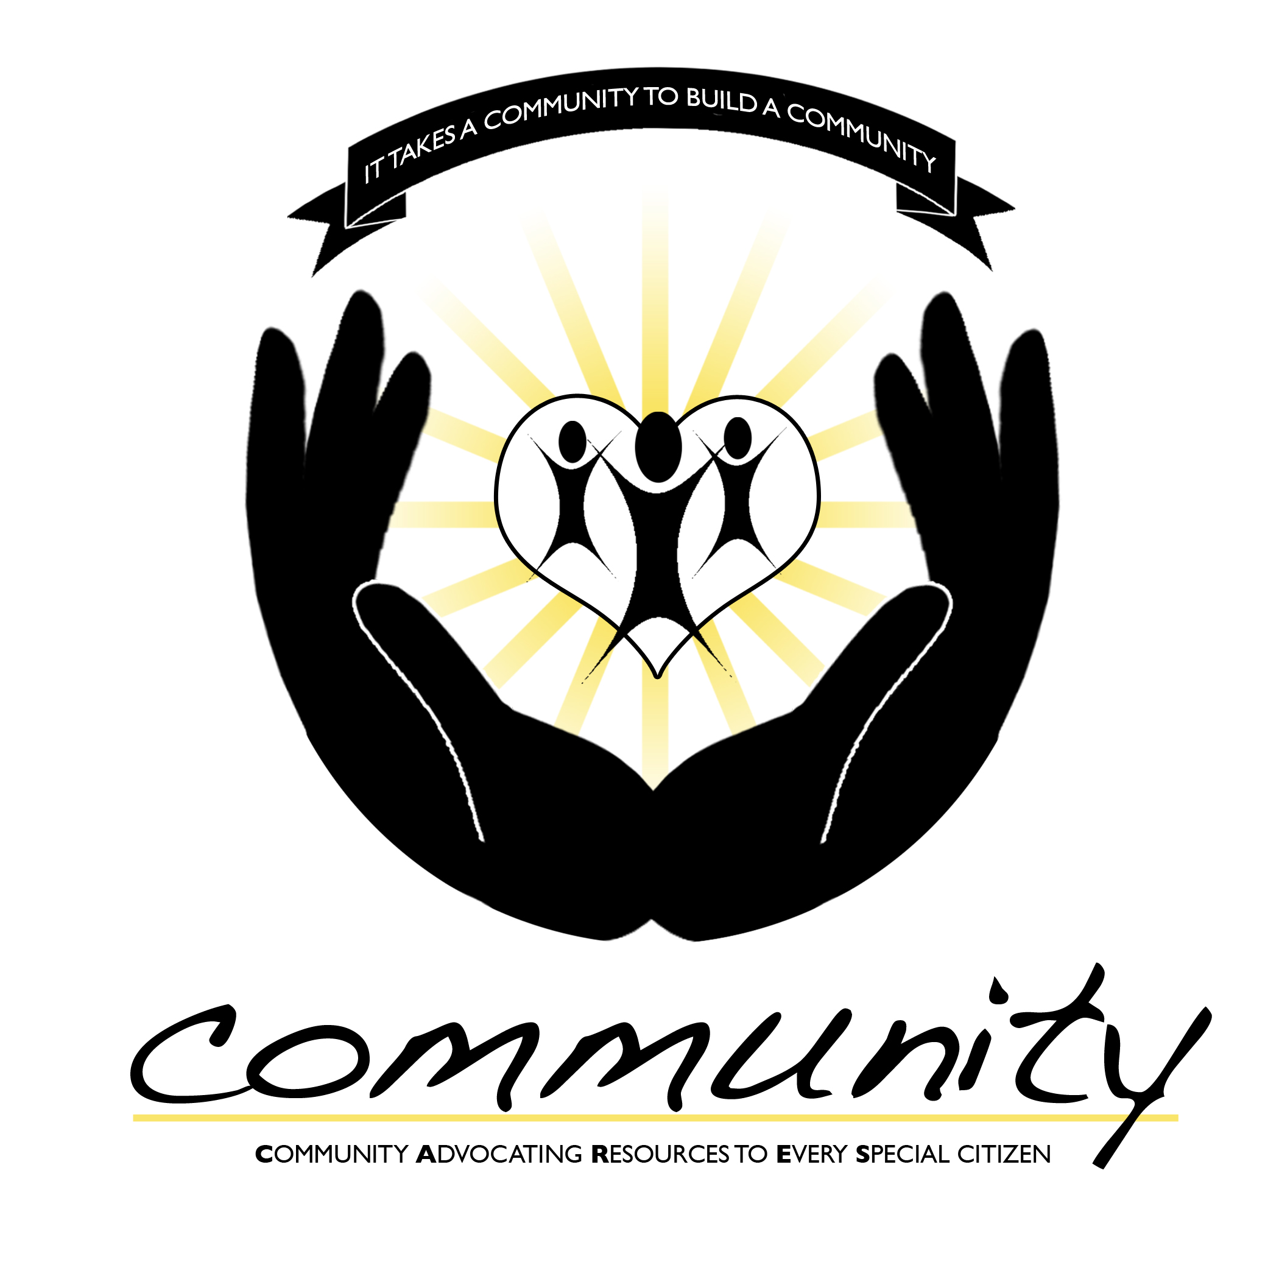

July 27, 2022

Dear Business Partners,
The Clarksville Association for Down syndrome and City of Clarksville Parks and Recreation have partnered together for the 10th Annual Community CARES Walk & Expo, a community event for our special citizens “Community CARES” (Community Advocating for Every Special Citizen). The objective of Community CARES is to provide awareness to our special citizens and the community about health, wellness, safety, education and much more.

We hope you would be willing to participate in our event by bringing out your business mascot. The Community Cares Walk & Expo is a family oriented event and your participation will provide great exposure to your business.

As you may be aware the Clarksville Association for Down syndrome (CADS) has been providing support to local families since 2009. We are a 501c3 non-profit organization and the primary source of funding for CADS is from corporate sponsors, such as yourself. Community CARES helps enable us to bring a multitude of programs to our community and surrounding area. The funds provided by this event will give us the ability to spread our mission and provide the following programs to our community:

- Totes for Teaching – New, expecting and newly relocated parents receive a tote packed with necessary information and available support services regarding Down syndrome.
- Technology for Teachers – We have been putting technology in special education classrooms for three years!! Over the past eighteen months CADS has awarded over 167 iPADS to Special Education teachers through this grant to support positive educational outcomes for all children with disabilities. CADS was recognized by the Clarksville Montgomery County School System and was presented with the Points of Pride award for our work and contributions to education.
- Making Memories Program – CADS partners with Camp for Courageous Kids in Scottsville Ky. Families with a Down syndrome member sometimes face financial and other hardships. CADS provides an all-inclusive retreat experience for at least 15 families, so they can make lasting memories and revitalize their family spirit.
- CADS is now focusing its energy on the Community CARES Clubhouse. A Clubhouse for individuals with disabilities to come and feel typical. The Clubhouse will offer Art, Music, Reading programs, playroom, and much more. All programs offered will be FREE. We’re dreaming BIG, and we need the support of the community to make these dreams a reality!

Thank you in advance for your time and consideration to this request. We hope this will be the first of many partnerships. Should you have any questions please feel free to reach out to me.
Sincerely,

Patricia Hanna
Executive Director
cadstn@hotmail.com
931.624.1693
www.cadstn.org

Mascot Commitment Form Event – Saturday, October 29, 2022
8:30am – 12:00pm
Wilma Rudolph Event Center, Liberty Park, Clarksville, TN
Yes! We would like to attend the Community CARES Walk & Expo.
Mascot Name: _______________________________________________
Mascot Type: ________________________________________________ (Animal, dinosaur)
Special Requests: ____________________________________________
Time Frame: 8:00am – 11:00 a.m. Yes
Other: ______________ Yes

Any time frame you can be present would be greatly appreciated. If you can’t commit to the above time frame, please write in what time you would be available. (We will have a private cool down room for all our mascot friends).

Contact name_________________________ Contact Title_______________________

Organization/Business Name:________________________________________

Street address______________________City______________State____Zip________

Telephone________________Email________________________Fax______________

Please return this form to CADS by Friday October 7, 2022. Scan or email your reply to cadstn@hotmail.com or mail to 1317 Sun Valley Road, Clarksville, TN 37040.
If you have any questions please contact Patricia Hanna at 931.624.1693

