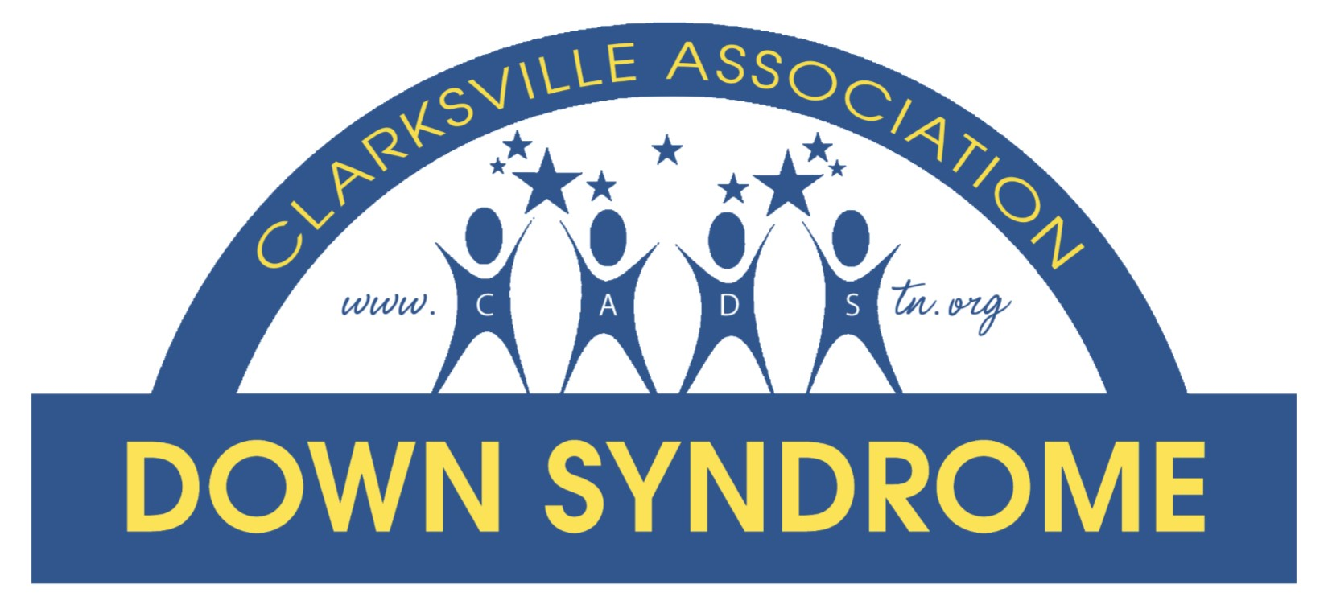 June 23, 2025
Dear Community Leader,
We are EXCITED to announce the 12th Annual Community CARES Walk. Our annual event is a huge success with over 65 vendors participating in the expo and more than 1,000 walkers, walking to make a difference for our entire community. We anticipate the 2025 Walk to be our biggest yet! Our goal is to provide continued awareness to our special citizens and the community about health, wellness, safety, education and much more. This event is a perfect opportunity for local merchants, businesses and organizations to market their services to the community as well as the special needs population and their families.

We invite you to become a sponsor of the Community CARES Walk and Expo.
Saturday, October 18, 2025
Wilma Rudolph Event Center at Liberty Park
1:00pm – 4:00pm

As you may be aware, the Clarksville Association Down syndrome (CADS) has been providing support to local families since 2009. The Clarksville Association Down syndrome receive no government funds for their efforts. The primary source of funding for CADS is from corporate sponsors, grants, and donations. CADS is a 501c3 non-profit organization. Community CARES helps enable us to bring a multitude of programs to our community and counties we serve. Below is a just a short list of the many opportunities we have been able to provide due to your generosity:
- Meetings/Gatherings- monthly support meeting for parents, pool parties, Moms night out, Christmas party and an annual Funfest for families to build comradery and friendships.
- Tech for Teens – In conjunction with APSU – Speech/Language department students with a disability learn how to use technology to facilitate post high school successes in employment, education and leisure activities.
- Making Memories Program – CADS partners with Camp for Courageous Kids in Scottsville Ky. Families with a Down syndrome member sometimes face financial and other hardships. CADS provides an all-inclusive retreat experience for at least 15 families, so they can make lasting memories and revitalize their family spirit.
- FREE Community Programs – CADS is now offering FREE programs to the entire special needs community. Our programs offer a wide range of fun filled activities. All programs are FREE and take place at various community locations.
- CADS is also focusing its energy on the Community CARES Clubhouse. A Clubhouse for individuals with disabilities to come and feel typical. Once the Clubhouse is open we will offer our programs at the Clubhouse. All programs offered will be FREE! We’re dreaming BIG, and we need the support of the community to make these dreams a reality!

Your sponsorship will help assure the success of the event, proceed with the above programs, create new programs and enable us to continue to provide awareness to a great cause. Enclosed please find more information on this exciting event and its sponsorship levels. Please do not hesitate to contact me with any questions or concerns.

Thank you in advance for your time and consideration to this request.
Sincerely,
Lily Wellington CADS Board
931.624.1590
www.cadstn.org

Community CARES Sponsorship packages:

Diamond Level $5,000 (Monetary or In-kind)
Your business name or logo prominently displayed in advertisements including:
- Logo placement on CADS website
- Prime location signage at the event
- Live mentions of your business throughout the event
- 20 x 20 booth space at the event
- Your logo in the Event program
- Your business name mentioned on promotional advertising
- Acknowledgement with Media advertisement as available

Platinum Sponsorship $2,500 (Monetary or In-kind)
Your business name or logo prominently displayed in advertisements including:
- Logo placement on CADS website
- Your logo on Signage around the walk event
- Live mentions of your business throughout the event.
- 10 x 10 booth space with prime location in event center
- Logo placement in Event Program
- Your company logo on all event printed materials

Gold $1,000 (Monetary or In-kind)
Your business name or logo prominently displayed in advertisements including:
- Live mentions of your business throughout the event
- 10 x 10 booth space at the event
- Logo in the Event Program

Silver Sponsorship $500 (Monetary or In-kind)
Your business name or logo prominently displayed in advertisements including:
- Live mentions of your business throughout the event
- Business name in Event Program
- 10 x 10 booth space at the event

Bronze Sponsorship $250 (Monetary or In-kind)
Your business name or logo prominently displayed in advertisements including:
- Logo in the Event Program
- 10x10 booth space at the event (per your request)

Sponsor Reply Form
Yes! We would like to sponsor Community CARES for the following amount:
___ Diamond Level $5,000 level
___ Platinum Level $2,500 level
___ Gold Level $1,000 level
___ Silver Level $500 level
___ Bronze Level $250 level

Name of Sponsor exactly as it should be listed in the program book and other recognition pieces: Please send your company logo to cadstn@hotmail.com in (JPEG format)
Contact name: ___________________ Contact Title: _______________________
Organization/Business Name: __________________________________________
Street address______________________City______________State____Zip________
Telephone______________Email______________________Fax____________
Special requests (such as electrical outlets): ___________________________

To ensure maximum recognition, please return this form by, October 1, 2025 unless other arrangements have been made. Payment is required by October 18, 2025, unless other arrangements have been made with CADS. Please email this form to cadstn@hotmail.com.
Please send your logo to cadstn@hotmail.com.

If you have any questions please contact Patricia Hanna at 931-624-1693 or visit www.cadstn.org.

**All contributions are tax deductible. Our EIN # 46-0574631, State Solicitation of funds for Charitable Purposes # CO18825.

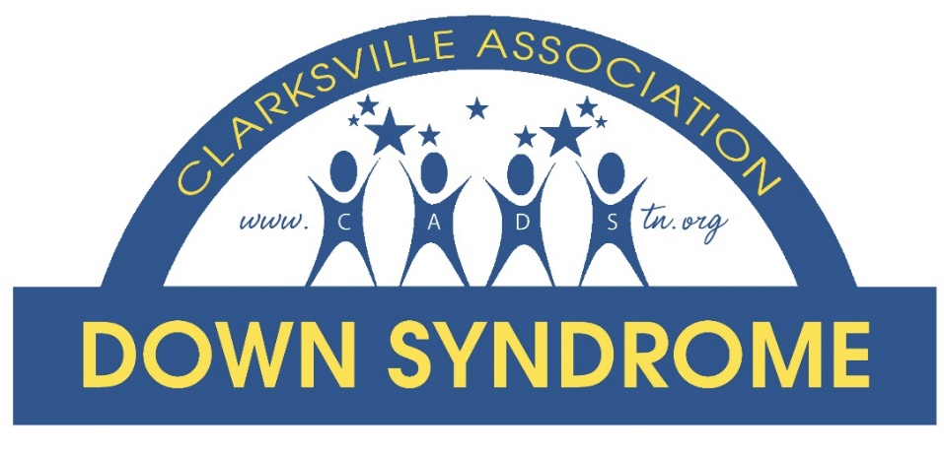
The mission of the Clarksville Association Down Syndrome Inc., is to educate and create a support network for individuals with Down syndrome their families and the community.
- Founded 2009
- Non Profit 2012
- EIN 460574631
- Serving over 130 families
- CADS is 100% volunteer lead, no paid administration.
- We are funded by grants, corporate sponsors and community support.
- We are independent of any agencies.
- CADS received the Points of Pride award from CMCSS in 2014 for our support to special education teachers. Helping enhance the teacher’s ability to instruct students with all special needs.
Counties Served: Montgomery, Cheatham, Robertson, Dickson, Todd KY, Christian KY, Stewart, Houston, Ft. Campbell, KY.

Programs:
Monthly support meetings @ Chuck E Cheese
Pool Parties – June thru August
Parents Night Out
Mom’s night out
Annual Family Funfest
Ghoulish Gala
Annual Christmas Party
CADS D.A.D.S. (Dads & Down Syndrome)

Totes for Teaching: A program implemented to give new parents and transient families in the area a tote and teddy bear. The tote offers resources within our community that families can utilize to meet the needs of their special needs family member.
Making Memories Program - CADS partners with Camp for Courageous Kids in Scottsville Ky. Families with a Down syndrome member sometimes face financial and other hardships. CADS provides an all-inclusive retreat experience for at least 15 families, so they can make lasting memories and revitalize their family spirit.
FREE Community Programs – CADS is now offering FREE programs to our special needs community. All programs offer a wide range of fun filled topics. Our programming is offered FREE and takes place in a partnership with community businesses and organizations.
Community CARES Clubhouse: CADS is now focusing its energy on the Community CARES Clubhouse. A Clubhouse for individuals with disabilities to come and feel typical. The Clubhouse will offer Art, Music, Reading programs, playroom, and much more. All programs offered will be FREE.

For more information call CADS at 931-624-1693
Visit the website at www.cadstn.org.
 CADS Community

