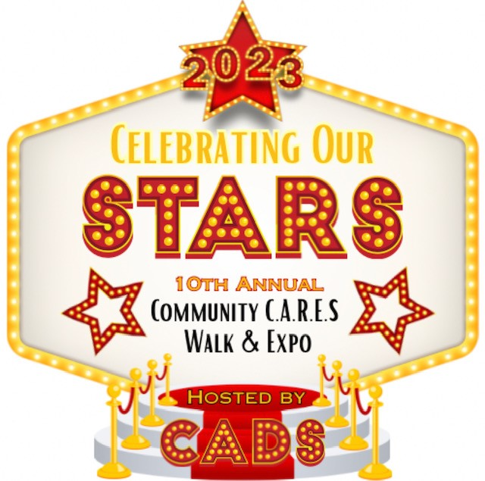
August 1, 2023
We are excited to announce the 10th Annual Community CARES Walk and Expo. The Clarksville Association Down syndrome is thrilled to promote Community CARES (Community Advocating Resources for Every Special Citizen) Walk and Expo. Our event in 2022 was a huge success with over 65 vendors participating in the expo and more than 1,000 walkers walking to make a difference. This year’s theme is “Celebrating Our Stars”. Our goal in hosting Community CARES is to provide resources and awareness to our special citizens and the community about health, wellness, safety, education and much more. The community is invited to participate in a walk around the pond at Liberty Park. It is our way of honoring all Special Citizens. After the walk the event is a perfect opportunity for local merchants to market their services to the general public as well as the special needs community.

As you may be aware the Clarksville Association for Down syndrome (CADS) has been providing support to local families since 2009. The Community CARES event and the Clarksville Association for Down syndrome receive no government funds for their efforts. The primary source of funding for CADS is from corporate sponsors, such as yourself. CADS is a 501c3 non-profit organization. All monies raised are tax deductible and 100% of the funds go back into the nine counties we live in and serve. Community CARES helps enable us to bring a multitude of programs to our community and surrounding area. The funds provided by this event will give us the ability to support our mission. Below is a just a short list of the many opportunities we have been able to provide due to your generosity:

- Totes for Teaching – New, expecting and newly relocated parents receive a tote packed with necessary information and available support services regarding Down syndrome.
- Technology for Teachers – We have been putting technology in special education classrooms for three years!! Since inception we have awarded167 IPads to Special Education teachers through this grant to support positive educational outcomes for all children with disabilities.
- Making Memories Program – Families with a Down syndrome member sometimes face financial and other hardships. CADS provides an all-inclusive retreat experience for at least 15 families, so they can make lasting memories and revitalize their family spirit.

We are asking businesses that can, to donate to this great cause for our Silent Auction. Your donation will help assure the success of the event, proceed with the above programs and enable us to continue to provide awareness to a great cause. All items donated are tax deductible and you will receive a receipt from the organization for the value of your donation. Please find attached a donation commitment form. If you are willing to donate an item/s for the Silent Auction please complete the form below and email or fax back to CADS. Please do not hesitate to contact me with any questions or concerns. The event this year is Saturday, October 28th from 8:30am – 11:30am at the Wilma Rudolph Event Center at Liberty Park

Thank you in advance for your time and consideration. We hope this will be the first of many partnerships.
Sincerely,

Patricia Hanna
Executive Director
cadstn@hotmail.com
931.624.1693
www.cadstn.org

Silent Auction Donation Commitment Form
Yes! We would like to donate to Community CARES for the following:

Organization/Business Name: ___________________________________________________

Point of Contact: ______________________ Contact Title: ___________________________

Address: ______________________City: ______________State: ______Zip: _____________

Telephone: ________________Email: ________________________Fax: ________________

Item/s Donating: ______________________________ Value of Donation: ________________

Item Description: _____________________________________________________________

Pick up location: _______________________ Date: _______________ Time: _____________

To ensure maximum recognition, please return this form as soon as possible to CADS. Scan and email to cadstn@hotmail.com
Community CARES Walk & Expo is Saturday, October 28th from 8:30am – 11:30am at the Wilma Rudolph Event Center at Liberty Park.
If you have any questions please contact Patricia Hanna at 931.624.1693

**All contributions are tax deductible. Our EIN # 46-0574631, State Solicitation of funds for Charitable Purposes # CO18825
____________________________________________________________________________
For Office Use Only
Item To Be Picked Up: Yes: ______ Date: _________________
Volunteer Receiving Item: _______________________________________
Donation Receipt: Delivered: _____ Mailed: ______

