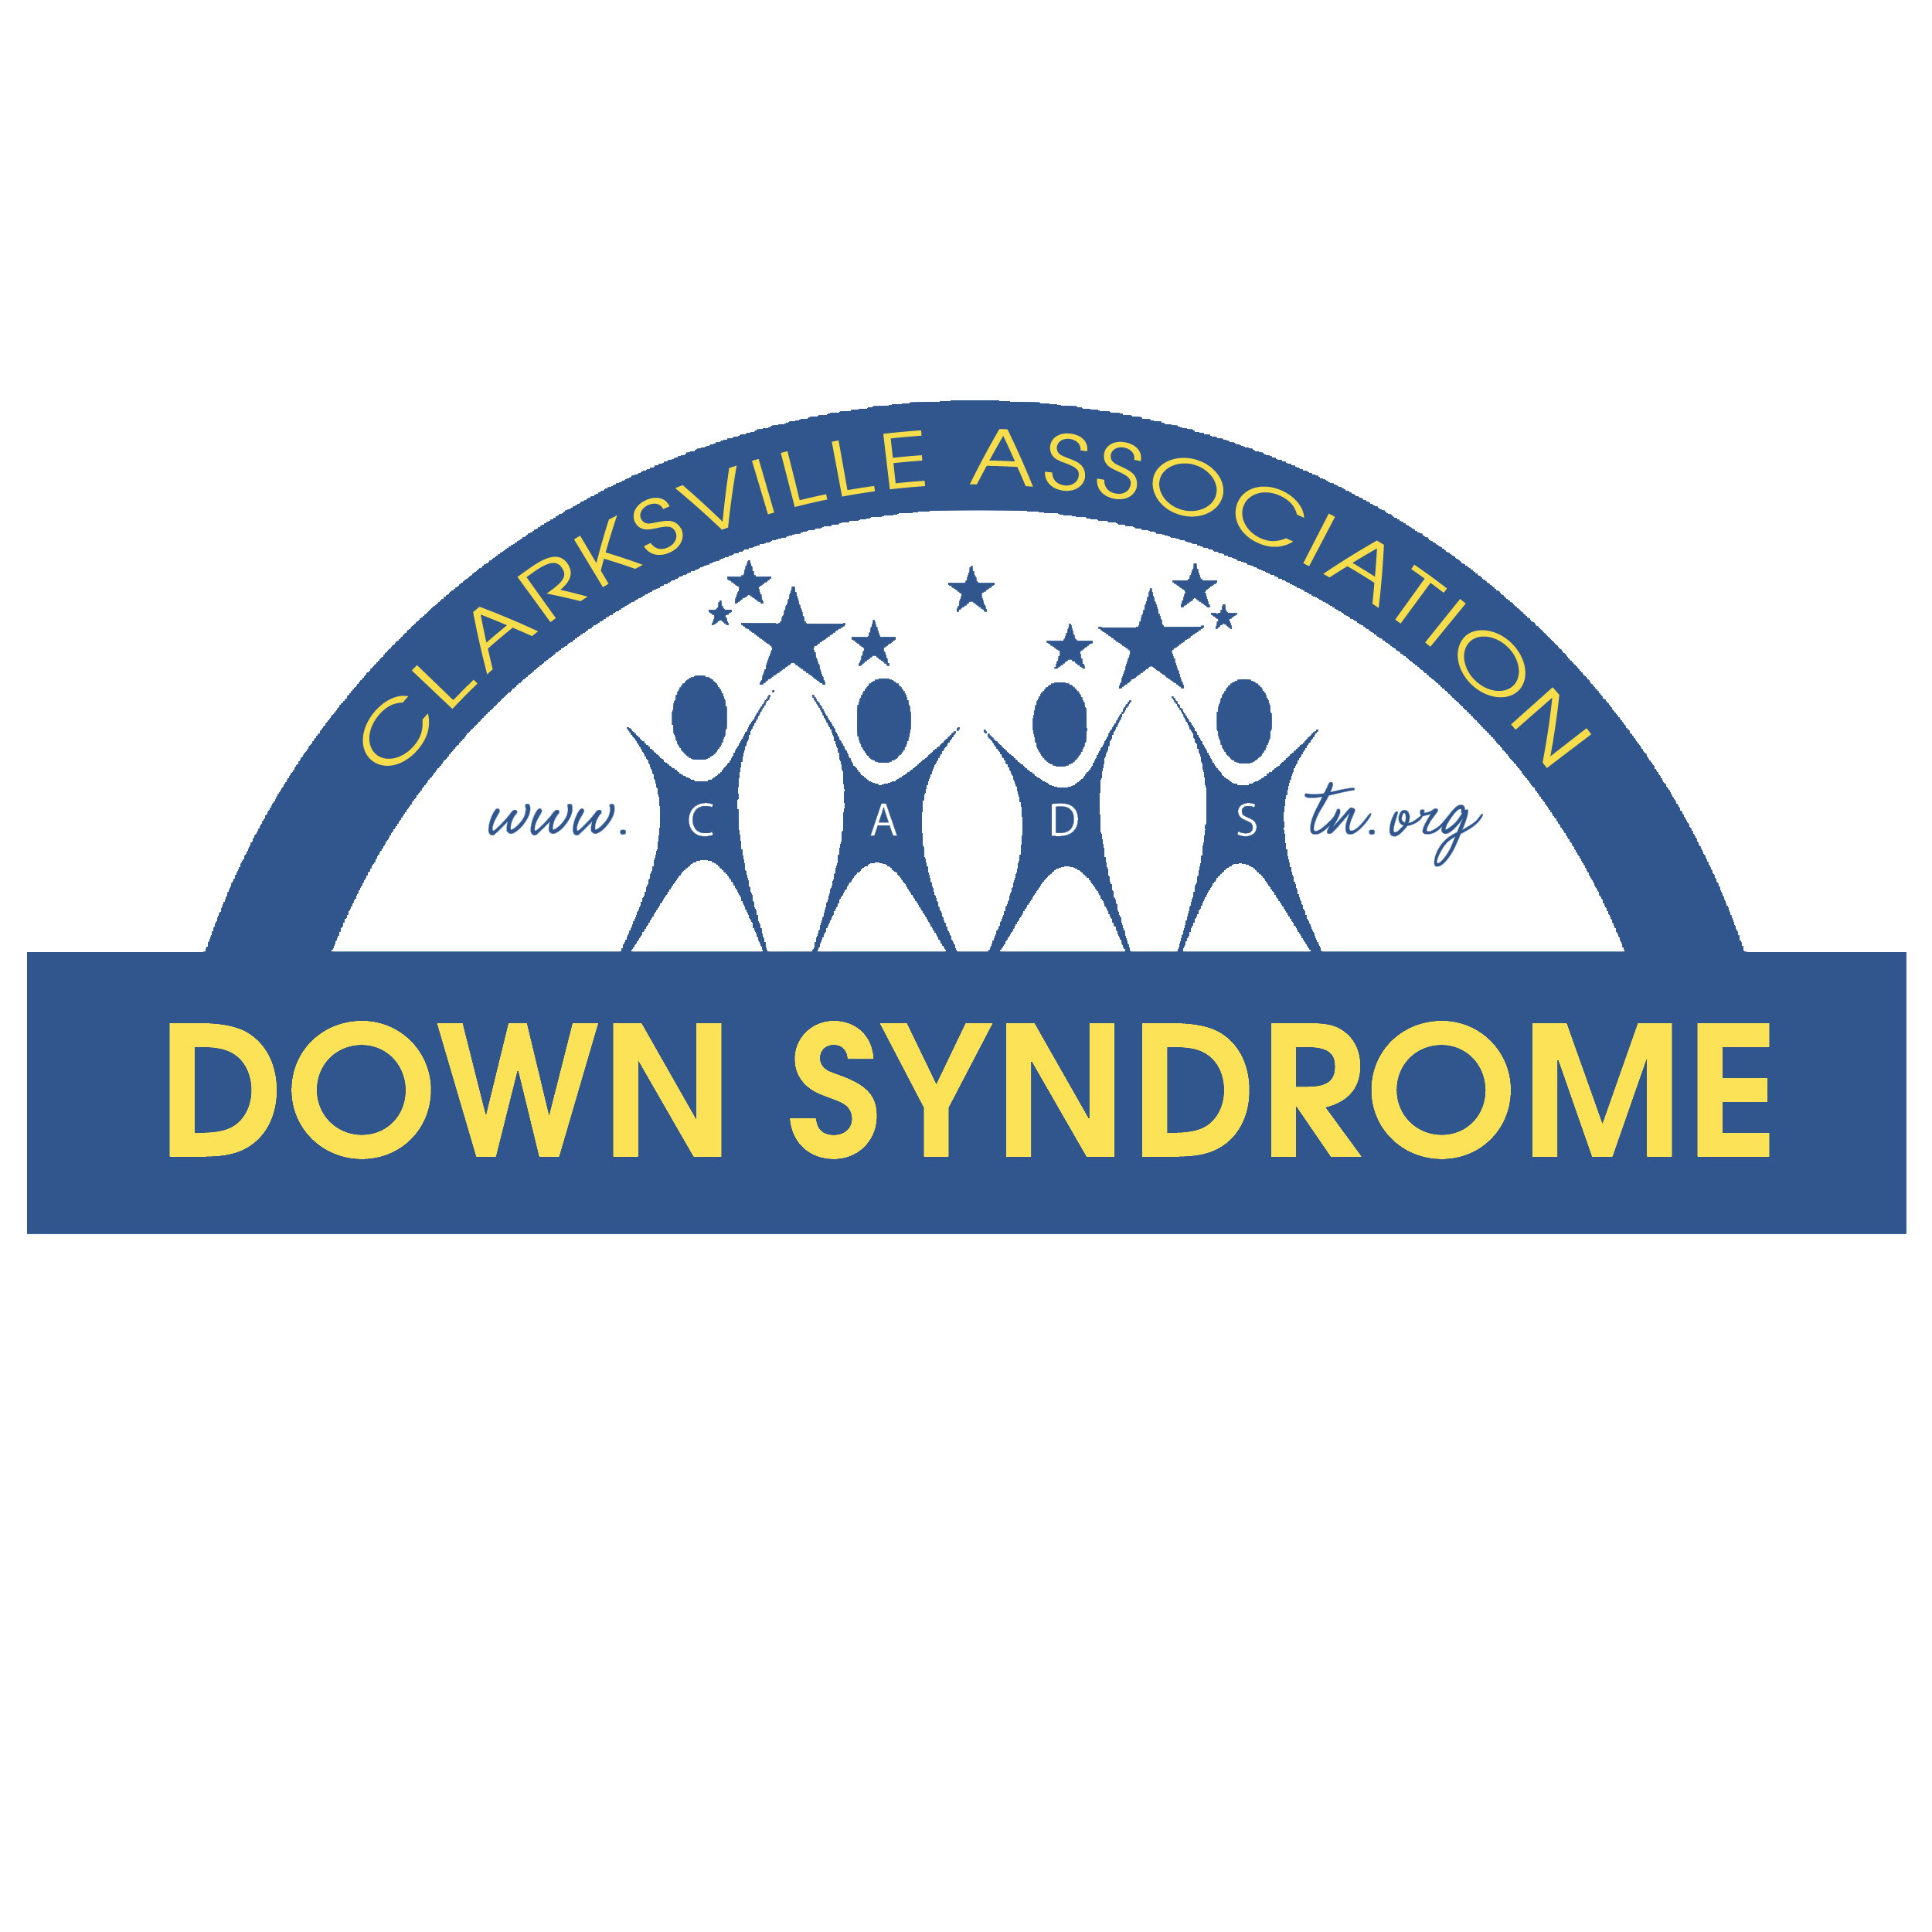

July 27, 2022

Dear Vendor,

After a two year hiatus we are excited to bring back to the community the 9th Annual Community CARES Walk and Expo. The Clarksville Association for Down syndrome is thrilled to promote Community CARES (Community Advocating Resources for Every Special Citizen) Walk and Expo. Our event in 2019 was a huge success with over 65 vendors participating in the expo and more than 1,000 walkers walking to make a difference. The theme and slogan for the 9th annual Walk is “To the Rescue! Celebrating our emergency services heroes!” Our goal in hosting Community CARES is to provide resources and awareness to our special citizens and the community about health, wellness, safety, education and much more. The community is invited to participate in a pledge walk around the pond at Liberty Park. It is our way of honoring all Special Citizens. After the walk the event is a perfect opportunity for local merchants to market their services to the general public as well as the special needs community.

The event will provide opportunities for area businesses to market the specific services they offer to Special Citizens and their families. We encourage you to participate in this exciting event and the first of its kind in Clarksville. Come support the Special Citizens of our community and educate them about the resources available to prepare and guide them for their future!

Saturday, October 29, 2022
8:30 am – 12:00 pm
Wilma Rudolph Event Center @ Liberty Park
Hwy 48/13

If you would like to participate in this event, please fill out the registration form attached and mail or fax it back to the address provided. There is NO fee for non-profit organizations, but we ask that you provide an activity for children at your booth.

Thank you in advance for your time and consideration. We hope this will be the first of many partnerships, please feel free to contact us at 931-645-1261.

Sincerely,

Patricia Hanna
Executive Director
cadstn@hotmail.com
931.624.1693
www.cadstn.org

Vendor Registration Form

Company/Org. Name: ______ POC: ________________________

Company/Org. Address: _ ___________ City: ________________State:____

Zip Code: ___ ___ Tel # ______________________ Fax# _________________

E-mail Business/Organization type: _______________________

Special requests (such as electrical outlets): ___________________________________

List Activity: _______________________________________________
Please check one:
______ No Fee for Non-profit organization must provide an activity for children.
______ A business/for profit organization

Space is limited so please reserve your booth today or no later than Friday, October 7, 2022! Please use one of the methods below to reserve your space, email to cadstn@hotmail.com or mail to the address below. You may also visit our website at www.cadstn.org. Once application is received you will receive confirmation that your space is reserved.
CADS
Attn: Patricia Hanna
1317 Sun Valley Road
Clarksville, TN 37040
If you have any questions, please call 931-624.1693

Space will include: 1 6ft or 8ft table, 2 chairs, and one table top sign. Electrical outlets available upon request limited number available.

Once registration is obtained you will receive confirmation that your space is reserved for the event. Payment is due with registration or at the day of the event. Make checks payable to CADS. No merchandise can be sold at the event, however you could have participants register at your table for a door prize so you have contact information.

The mission of the Clarksville Association Down Syndrome Inc., is to educate and create a support network for individuals with Down Syndrome their families and the community.

Quick Facts about CADS:

As you may be aware the Clarksville Association for Down syndrome (CADS) has been providing support to local families since 2009. The Community CARES event and the Clarksville Association for Down syndrome receive no government funds for their efforts. The primary source of funding for CADS is from corporate sponsors, such as yourself. CADS is a 501c3 non-profit organization. All monies raised are tax deductible and 100% of the funds go back into the nine counties we live in and serve. Community CARES helps enable us to bring a multitude of programs to our community and surrounding area. The funds provided by this event will give us the ability to support our mission. Below is a just a short list of the many opportunities we have been able to provide due to your generosity:

- Monthly Meetings - CADS offers a monthly support meeting for parents, children and siblings.

- Totes for Teaching – New, expecting and newly relocated parents receive a tote packed with necessary information and available support services regarding Down syndrome.

- Technology for Teachers – We have been putting technology in special education classrooms for two years!! Over the past eighteen months CADS has awarded over 167 iPads to Special Education teachers through this grant to support positive educational outcomes for all children with disabilities. CADS was recognized by the Clarksville Montgomery County School System and was presented with the Points of Pride award for our work and contributions to education.

- Tech for Teens – In conjunction with APSU – Speech/Language department students with a disability learn how to use technology to facilitate post high school successes in employment, education and leisure activities.

- Drive by Santa – Families are able to drive by in the safety of their vehicle visiting Santa’s friends and gathering goodies along the way and at the final stop they are able to take pictures with Santa and Mrs. Clause.

- Making Memories Program – CADS partners with Camp for Courageous Kids in Scottsville Ky. Families with a Down syndrome member sometimes face financial and other hardships. CADS provides an all-inclusive retreat experience for at least 15 families, so they can make lasting memories and revitalize their family spirit.

- FREE Community Programs – CADS is now offering FREE monthly programs to our special needs community. All programs run for 4 consecutive weeks and offer a wide range of fun filled topics. Our programming is offered FREE and takes place in a partnership with Clarksville Parks and Recreation and are held at the Crow Center.

- CADS is also focusing its energy on the Community CARES Clubhouse. A Clubhouse for individuals with disabilities to come and feel typical. Once the Clubhouse is open we will offer our programs at the Clubhouse. All programs offered will be FREE! We’re dreaming BIG, and we need the support of the community to make these dreams a reality!

